

International School

**Capstone Project 1**

CMU-CS450

**User Interface Design Document**

**Version 1.3**

**Date:** 08/11/2022

**Craft Village Pollution Monitor System**

**Submitted by**

**Ca, Van Cong Le**

**Huy, Bui Duc**

**Phuc, Hua Hoang**

**Trung, Nguyen Thanh**

**Approved by**

**Ph.D. Nguyen Thanh Binh**

**Proposal Review Panel Representative:**

Name Signature Date

**Capstone Project 1 - Mentor:**

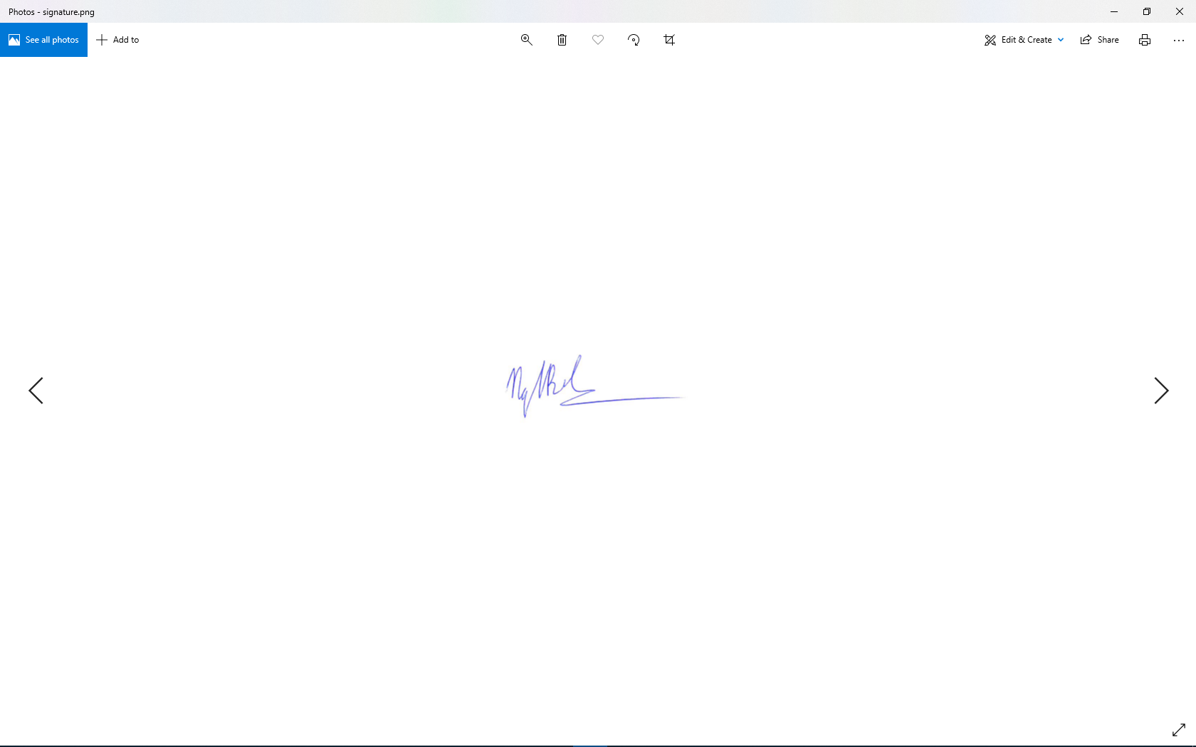

Name Signature Date

**PROJECT INFORMATION**

|  |  |  |  |
| --- | --- | --- | --- |
| **Project acronym** | CVPMS | | |
| **Project Title** | Craft Village Pollution Monitor System | | |
| **Start Date** | 22/08/2022 | **End Date** | 07/12/2022 |
| **Lead Institution** | International School, Duy Tan University | | |
| **Project Mentor** | Ph.D. Thanh Binh, Nguyen | | |
| **Scrum master / Project Leader & contact details** | Ca, Van Cong Le  *Email:* cascabusiness@gmail.com  *Tel:* 0352707895 | | |
| **Partner Organization** |  | | |
| **Project Web URL** | [*https://github.com/Casca113s2/craft-village-pollution-monitor-system*](https://github.com/Casca113s2/craft-village-pollution-monitor-system) | | |
| **Team members** | **Name** | **Email** | **Tel** |
| 25211207666 | Ca, Van Cong Le | [cascabusiness@gmail.com](http://cascabusiness@gmail.com) | 0352707895 |
| 25211215894 | Huy, Bui Duc | [duchuyltt122@gmail.com](http://duchuyltt122@gmail.com) | 0818648090 |
| 25211204084 | Phuc, Hua Hoang | [phuchuho0402@gmail.com](http://phuchuho0402@gmail.com) | 0905639682 |
| 25211215133 | Trung, Nguyen Thanh | [nguyenttrung2601@gmail.com](http://nguyenttrung2601@gmail.com) | 0774496838 |

DOCUMENT NAME

|  |  |  |  |
| --- | --- | --- | --- |
| **Document Title** | User Interface Design Document | | |
| **Author(s)** | Nguyen Thanh Trung | | |
| **Date** | 08/11/2022 | **File Name** | C1SE.06_CVPMS_User-Interface-Design-Document_v1.3.docx |

REVISION HISTORY

| **Version** | **Date** | **Comments** | **Author** | **Approval** |
| --- | --- | --- | --- | --- |
| 1.0 | 18/09/2022 | Create Document | Nguyen Thanh Trung |  |
| 1.1 | 05/10/2022 | Update Document (Survey page) | Nguyen Thanh Trung |  |
| 1.2 | 22/10/2022 | Create survey system (Survey page, Register page) | Nguyen Thanh Trung |  |
| 1.3 | 08/11/2022 | Create survey system (Survey page, Homepage) | Nguyen Thanh Trung |  |

**Approve Document:** Sign in to approve document

|  |  |  |  |
| --- | --- | --- | --- |
| **Mentor** | Binh, Nguyen Thanh | Date | 08/11/2022 |
| Sign |  |
| **Scrum Master** | Ca, Van Cong Le | Date | 08/11/2022 |
| Sign |  |
| **Scrum Member** | Huy, Bui Duc | Date | 08/11/2022 |
| Sign |  |
| **Scrum Member** | Phuc, Hua Hoang | Date | 08/11/2022 |
| Sign |  |
| **Scrum Member** | Trung, Nguyen Thanh | Date | 08/11/2022 |
| Sign |  |

**Table Of Contents**

1. Introduction 8

1.1. Purpose 8

1.2. Scope 8

2. List of User Interface 8

2.1. Private User 8

2.2. Local Authority 9

2.3. Household 10

2.4. Admin 10

3. Describe the User Interface 11

3.1. Private User 11

3.1.1. Login 11

3.1.2. Sign Up 13

3.1.3. Forget password page 15

3.1.4. Home page 17

3.1.5. View all finished survey 19

3.1.6. Sidebar 21

3.1.7. Change password 23

3.1.8. Edit profile 25

3.1.9. Survey page 27

3.2. Local Authority 33

3.2.1. Login Page 33

3.2.2. Change Password Page 34

3.2.3. Local Authority Home Page 35

3.2.4. Village Management Page 36

3.3. Household 37

3.3.1. Login Page 37

3.3.2. Change Password Page 38

3.3.3. Register Page 39

3.3.4. Household Survey Page 40

3.4. Admin 41

3.4.1. Login Page 41

3.4.2. Change Password Page 42

3.4.3. Create New Local Authority Page 43

Table Of Figures

**Figure 1.** UI Login 11

**Figure 2.** UI Sign Up 13

**Figure 3.** UI Forget Password 15

**Figure 4.** UI Home page 17

**Figure 5.** UI View All Finished Survey 19

**Figure 6.** UI Sidebar 21

**Figure 7.** UI Change Password 23

**Figure 8.** UI of Edit Profile 25

**Figure 9.** UI of Survey Page 1 27

**Figure 10.** UI of Survey Page 2 29

**Figure 11.** UI of Survey Page 3 31

**Figure 12.** UI of Login Page on Website 33

**Figure 13.** UI of Change Password Page 34

**Figure 14.** UI of Local Authority Home Page 35

**Figure 15.** UI of Village Management Page 36

**Figure 16.** UI of Login Page on Website 37

**Figure 17.** UI of Change Password Page 38

**Figure 18.** UI of Register Page 39

**Figure 19.** UI of Survey Page 40

**Figure 20.** UI of Login Page on Website 41

**Figure 21.** UI of Change Password Page 42

**Figure 22.** UI of Create New Local Authority Page 43

Table Of Tables

**Table 1.** List of Private User User Interface 8

**Table 2.** List of Local Authority User Interface 9

**Table 3.** List of Household User Interface 10

**Table 4.** List of Admin User Interface 10

**Table 5.** Element of UI Login 12

**Table 6.** Elements of UI Sign Up 14

**Table 7.** Elements of UI Forget Password 16

**Table 8.** Elements of Home Page 18

**Table 9.** Elements of View All Finished Survey 20

**Table 10.** Elements of UI Sidebar 22

**Table 11.** Elements of UI Change Password 24

**Table 12.** Elements of UI Edit Profile 26

**Table 13.** Elements of Survey Page 1 28

**Table 14.** Elements of UI Survey Page 2 30

**Table 15.** Elements of UI Survey Page 3 32

**Table 16.** Elements of UI Login on Website 33

**Table 17.** Elements of UI Change Password Page 34

**Table 18.** Elements of UI Local Authority Home Page 35

**Table 19.** Elements of UI Village Management Page 36

**Table 20.** Elements of UI Login Page on Website 37

**Table 21.** Elements of UI Change Password Page 38

**Table 22.** Elements of UI Register Page 39

**Table 23.** Elements of UI Survey Page 40

**Table 24.** Elements of UI Login Page on Website 41

**Table 25.** Elements of UI Change Password Page 42

**Table 26.** Elements of UI Create New Local Authority Page 43

# **Introduction**

## Purpose

* This document helps to better understand the interface of the Comment Scraper Tool, detailed specification components and function of the system.
* With this document, the development team can understand detail the structure and composition to create a consistent and complete system.

## Scope

* Overview of the stages and modules of the system.
* Create complete interfaces and describe them clearly.

# List of User Interface

## Private User

**Table 1.** List of Private User User Interface

|  |  |  |
| --- | --- | --- |
| **User Interface ID** | **UI Name** | **Description** |
| **Mobile** | | |
| UI-01 | Login page | This is the login page of the User |
| UI-02 | Sign up page | This page for user account registration |
| UI-03 | Forget password page | This page to receive the password of the used account |
| UI-04 | Home page | This page shows the new survey creation function and the number of completed surveys |
| UI-05 | View all finished survey | This page to see all the surveys that users have taken |
| UI-06 | Sidebar | This page includes the function of view personal information, logout and change password |
| UI-07 | Change password page | This page to change the password for the account in use |
| UI-08 | Edit profile page | This page to change personal information |
| UI-09 | Survey Page | This page for users to take surveys |
| **Website** | | |
| UI-10 | Login Page | This is the login page of the User |
| UI-11 | Change Password | This page to change the password for the account in use |

## Local Authority

**Table 2.** List of Local Authority User Interface

|  |  |  |
| --- | --- | --- |
| **User Interface ID** | **UI Name** | **Description** |
| UI-12 | Login | This is the login page of Local Authority |
| UI-13 | Change Password | This page to change the password for the account in use |
| UI-14 | Forget Password | This page to receive the password of the used account |
| UI-15 | Local Authority Home Page | This page to see statistics about craft villages |
| UI-16 | Village Management Page | This page allows local authorities to add, remove proposals or create new craft villages. |

## Household

**Table 3.** List of Household User Interface

|  |  |  |
| --- | --- | --- |
| **User Interface ID** | **UI Name** | **Description** |
| UI-17 | Login | This is the login page of Household |
| UI-18 | Change Password | This page to change the password for the account in use |
| UI-19 | Forget Password | This page to receive the password of the used account |
| UI-20 | Register Page | This page is used to register a new account for Household |
| UI-21 | Survey Page | This page allows household heads to register their craft villages or register new craft villages if that craft village does not exist in the database |

## Admin

**Table 4.** List of Admin User Interface

|  |  |  |
| --- | --- | --- |
| **User Interface ID** | **UI Name** | **Description** |
| UI-22 | Login | This is the login page of Admin |
| UI-23 | Change Password | This page to change the password for the account in use |
| UI-24 | Forget Password | This page to receive the password of the used account |
| UI-25 | Create New Local Authority Page | This page to create a new local authority account. |

# Describe the User Interface

## Private User

### Login

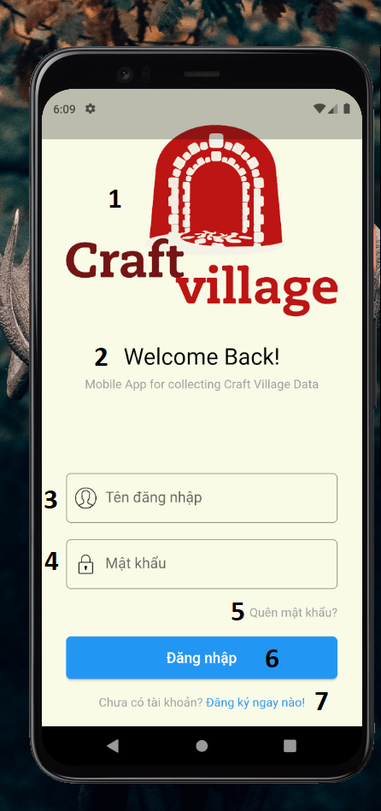

**Figure 1.** UI Login

**Table 5.** Element of UI Login

|  |  |  |  |  |
| --- | --- | --- | --- | --- |
| From | Condition | Control Type | Target | Notes |
| 1 | View | Image | Display image |  |
| 2 | View | Lable | Display text |  |
| 3 | Input | Textbox | Enter username |  |
| 4 | Input | Textbox | Enter password |  |
| 5 | Click | Hyperlink | Click to go to forget password page |  |
| 6 | Click | Button | Click to log in |  |
| 7 | Click | Hyperlink | Click to go to sign up page |  |

### Sign Up

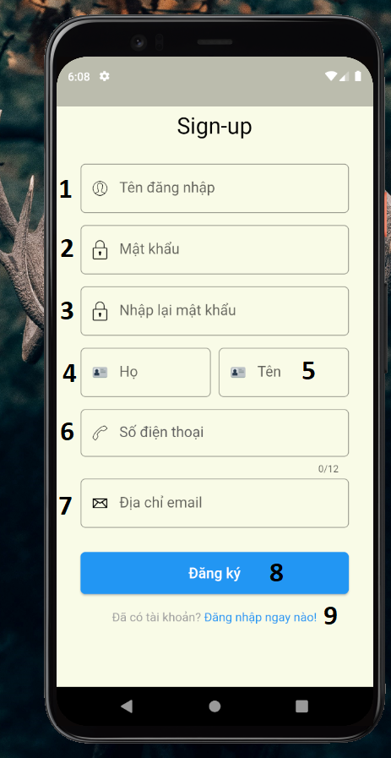

**Figure 2.** UI Sign Up

**Table 6.** Elements of UI Sign Up

|  |  |  |  |  |
| --- | --- | --- | --- | --- |
| From | Condition | Control Type | Target | Notes |
| 1 | Input | Textbox | Enter username |  |
| 2 | Input | Textbox | Enter password |  |
| 3 | Input | Textbox | Enter password |  |
| 4 | Input | Textbox | Enter first name |  |
| 5 | Input | Textbox | Enter last name |  |
| 6 | Input | Textbox | Enter phone number |  |
| 7 | Input | Textbox | Enter email address |  |
| 8 | Click | Button | Click to register account |  |
| 9 | Click | Hyperlink | Click to go to log in page |  |

### Forget password page

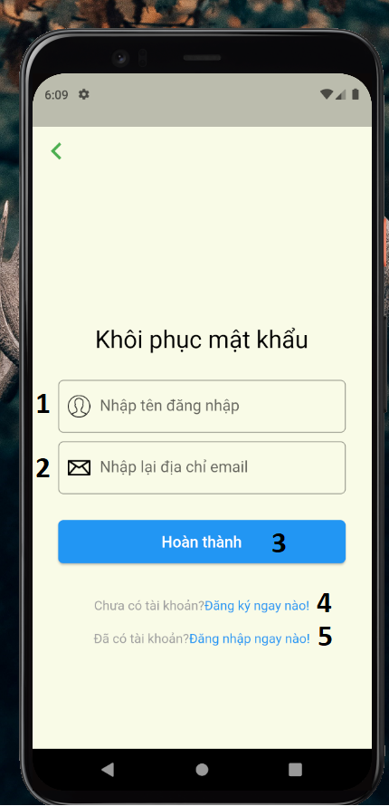

**Figure 3.** UI Forget Password

**Table 7.** Elements of UI Forget Password

|  |  |  |  |  |
| --- | --- | --- | --- | --- |
| From | Condition | Control Type | Target | Notes |
| 1 | Input | Textbox | Enter username |  |
| 2 | Input | Textbox | Enter email address |  |
| 3 | Click | Button | Click to receive new password by email |  |
| 4 | Click | Hypertext | Click to go to the sign-up page |  |
| 5 | Click | Hypertext | Click to go to the login page |  |

### Home page

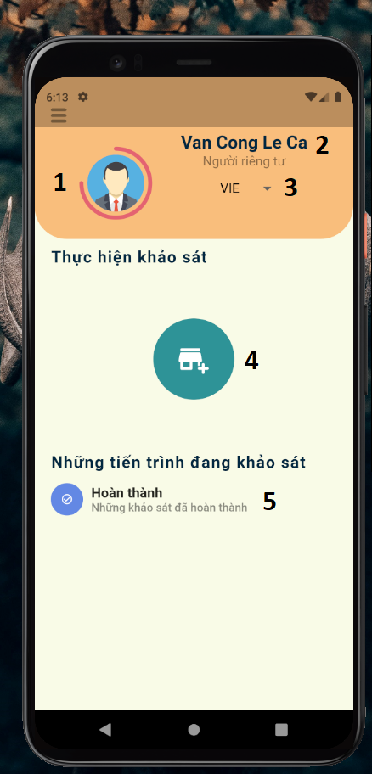

**Figure 4.** UI Home page

**Table 8.** Elements of Home Page

|  |  |  |  |  |
| --- | --- | --- | --- | --- |
| From | Condition | Control Type | Target | Notes |
| 1 | View | Image | Display profile picture |  |
| 2 | View | Lable | Display the first and last name of the user |  |
| 3 | Click | DropDownList | Click to select display language |  |
| 4 | Click | Image Button | Click to create a new survey |  |
| 5 | Click | Hyperlink | Click to view all finished survey |  |

### View all finished survey

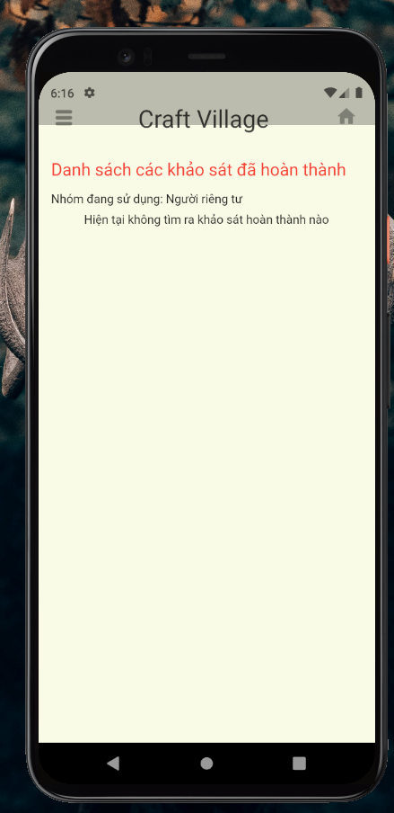

**Figure 5.** UI View All Finished Survey

**Table 9.** Elements of View All Finished Survey

|  |  |  |  |  |
| --- | --- | --- | --- | --- |
| From | Condition | Control Type | Target | Notes |
| 1 | Click | Button | Update class information |  |
| 2 | Click | Button | Delete class |  |

### Sidebar

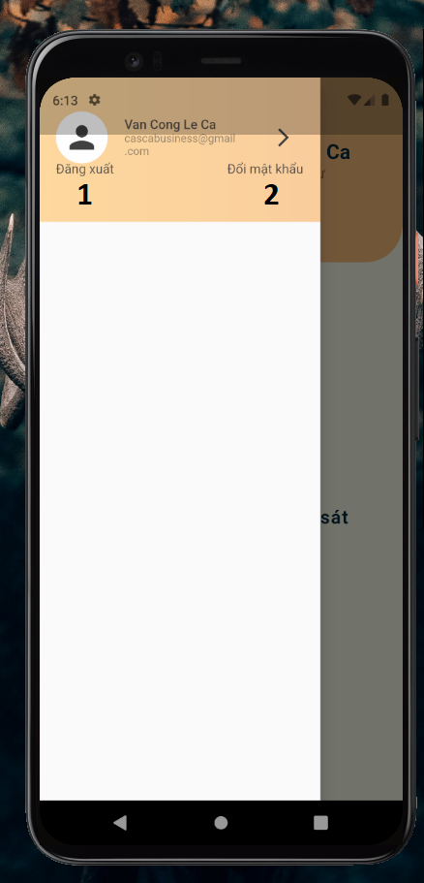

**Figure 6.** UI Sidebar

**Table 10.** Elements of UI Sidebar

|  |  |  |  |  |
| --- | --- | --- | --- | --- |
| From | Condition | Control Type | Target | Notes |
| 1 | Click | Hyperlink | Click to go to login page |  |
| 2 | Click | Hyperlink | Click to go to change password page |  |

### Change password



**Figure 7.** UI Change Password

**Table 11.** Elements of UI Change Password

|  |  |  |  |  |
| --- | --- | --- | --- | --- |
| From | Condition | Control Type | Target | Notes |
| 1 | Input | Textbox | Enter the current password |  |
| 2 | Input | Textbox | Enter the new password |  |
| 3 | Input | Textbox | Enter the new password again |  |
| 4 | Click | Button | Click to change password |  |

### Edit profile

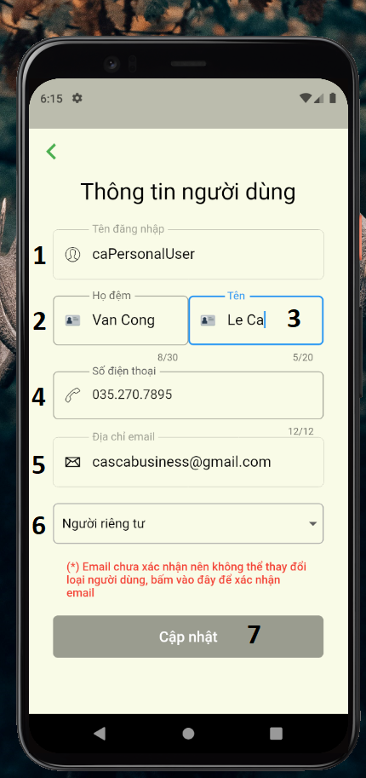

**Figure 8.** UI of Edit Profile

**Table 12.** Elements of UI Edit Profile

|  |  |  |  |  |
| --- | --- | --- | --- | --- |
| From | Condition | Control Type | Target | Notes |
| 1 | Input | Textbox | Enter the username |  |
| 2 | Input | Textbox | Enter the firstname |  |
| 3 | Input | Textbox | Enter the lastname |  |
| 4 | Input | Textbox | Enter the phone number |  |
| 5 | Input | Textbox | Enter the email address |  |
| 6 | Click | DropDownList | Click to choose the account type |  |
| 7 | Click | Button | Click to update personal information |  |

### Survey page

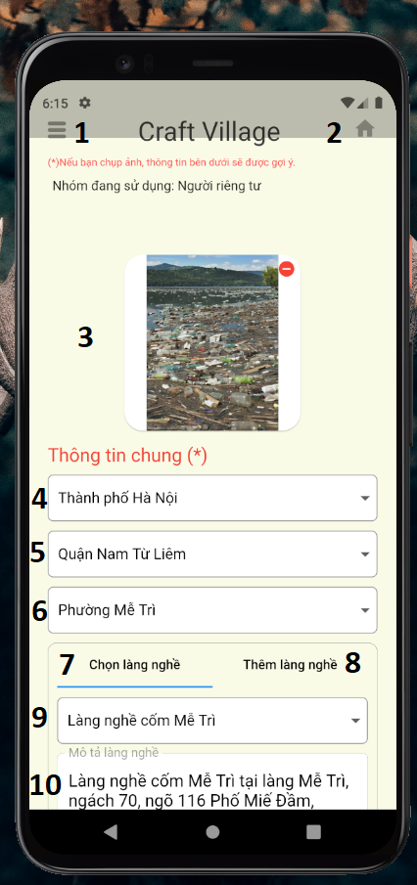

**Figure 9.** UI of Survey Page 1

**Table 13.** Elements of Survey Page 1

|  |  |  |  |  |
| --- | --- | --- | --- | --- |
| From | Condition | Control Type | Target | Notes |
| 1 | Click | ImageButton | Click to show the sidebar |  |
| 2 | Click | ImageButton | Click to go to the home page |  |
| 3 | Input | Image | Take a photo |  |
| 4 | Click | DropDownList | Click to select province/city |  |
| 5 | Click | DropDownList | Click to select district |  |
| 6 | Click | DropDownList | Click to select ward |  |
| 7 | Click | TaskButton | Click to fill in the information |  |
| 8 | Click | TaskButton | Click to fill in the new craft village information |  |
| 9 | Click | DropDownList | Click to select a craft village |  |
| 10 | Input | Textbox | Enter the description of the craft village |  |

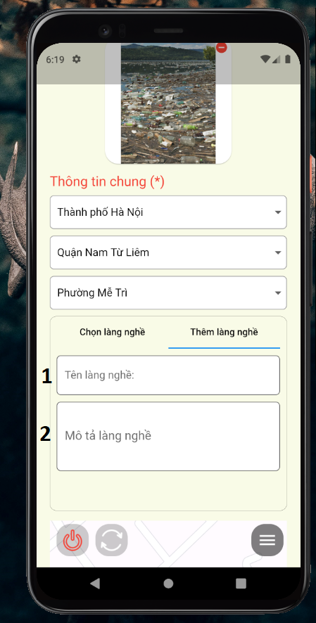

**Figure 10.** UI of Survey Page 2

**Table 14.** Elements of UI Survey Page 2

|  |  |  |  |  |
| --- | --- | --- | --- | --- |
| From | Condition | Control Type | Target | Notes |
| 1 | Input | Textbox | Enter the name of craft village |  |
| 2 | Input | Textbox | Enter the description of the craft village |  |

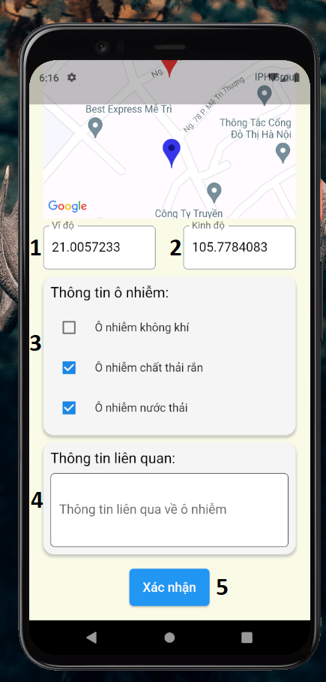

**Figure 11.** UI of Survey Page 3

**Table 15.** Elements of UI Survey Page 3

|  |  |  |  |  |
| --- | --- | --- | --- | --- |
| From | Condition | Control Type | Target | Notes |
| 1 | Input | Textbox | Enter latitude |  |
| 2 | Input | Textbox | Enter longitude |  |
| 3 | Click | RadioButtonList | Click to select pollution type |  |
| 4 | Input | Textbox | Enter relevant information about pollution |  |
| 5 | Click | Button | Click to confirm and submit the survey |  |

## Local Authority

### Login Page

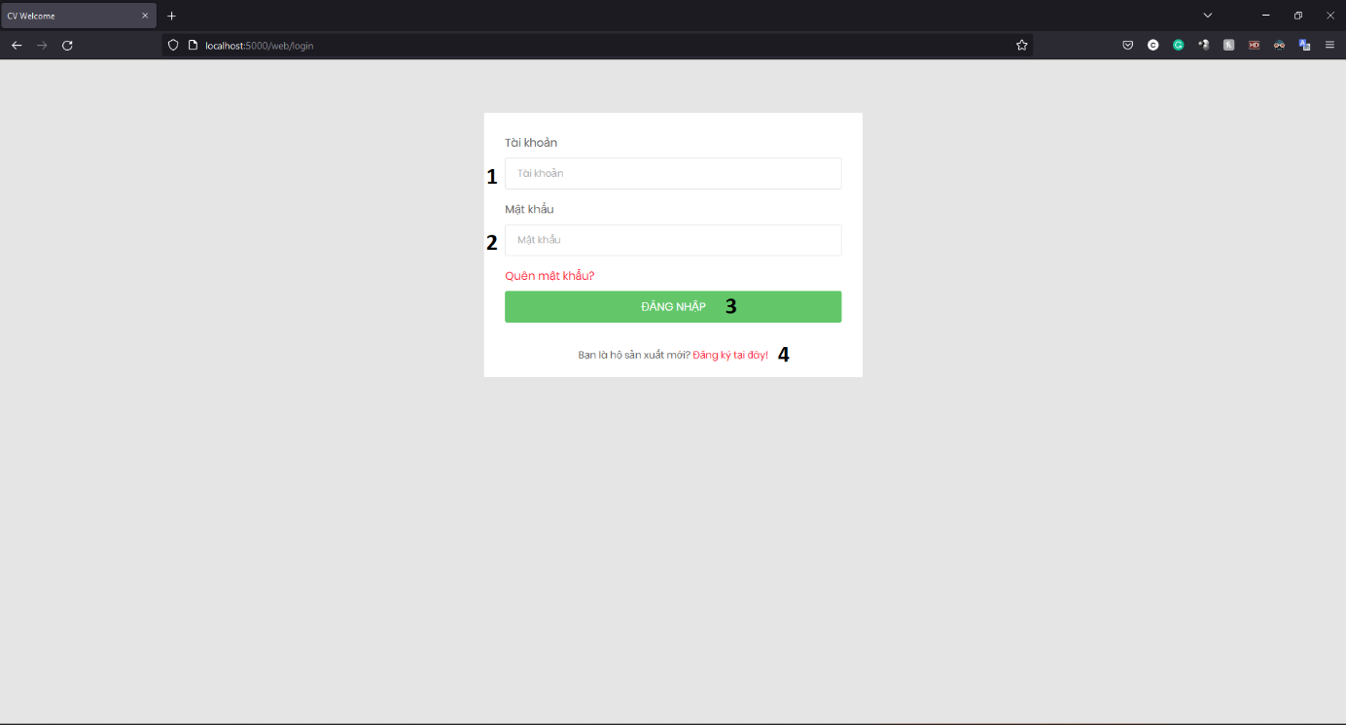

**Figure 12.** UI of Login Page on Website

**Table 16.** Elements of UI Login on Website

|  |  |  |  |  |
| --- | --- | --- | --- | --- |
| From | Condition | Control Type | Target | Notes |
| 1 | Input | Textbox | Enter the username |  |
| 2 | Input | Textbox | Enter the password |  |
| 3 | Click | Button | Click to go to home page |  |
| 4 | Click | Hyperlink | Click to go to register page |  |

### Change Password Page

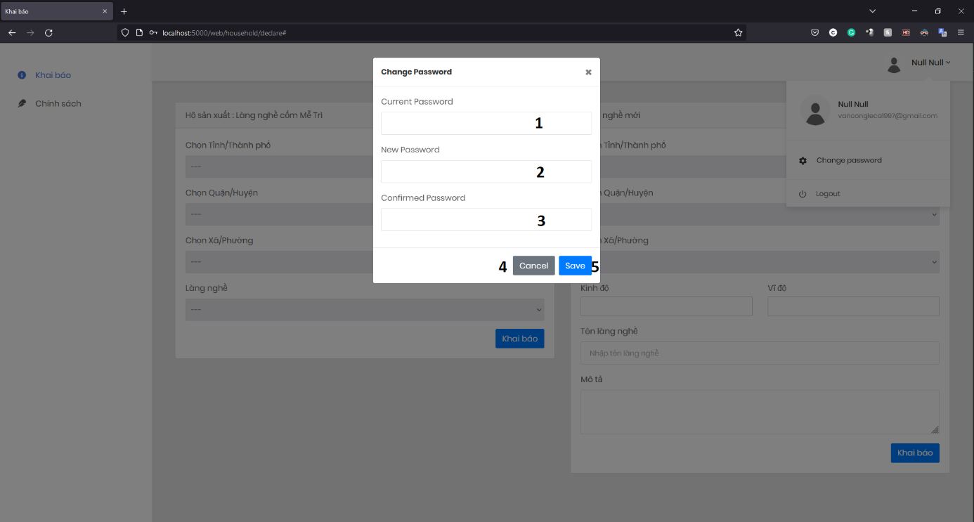

**Figure 13.** UI of Change Password Page

**Table 17.** Elements of UI Change Password Page

|  |  |  |  |  |
| --- | --- | --- | --- | --- |
| From | Condition | Control Type | Target | Notes |
| 1 | Input | Textbox | Enter the current password |  |
| 2 | Input | Textbox | Enter the new password |  |
| 3 | Input | Textbox | Enter the new password again |  |
| 4 | Click | Button | Cancel the password change operation |  |
| 5 | Click | Button | Click to change the password for the account |  |

### Local Authority Home Page

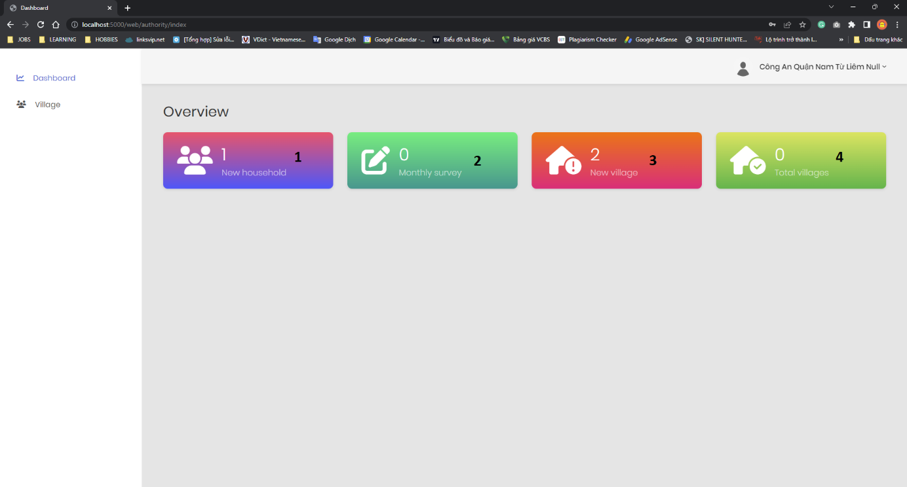

**Figure 14.** UI of Local Authority Home Page

**Table 18.** Elements of UI Local Authority Home Page

|  |  |  |  |  |
| --- | --- | --- | --- | --- |
| From | Condition | Control Type | Target | Notes |
| 1 | View | Lable | Display the number of new households |  |
| 2 | View | Lable | Display the number of surveys |  |
| 3 | View | Lable | Display the number of the new village |  |
| 4 | View | Lable | Display the total village of the ward |  |

### Village Management Page

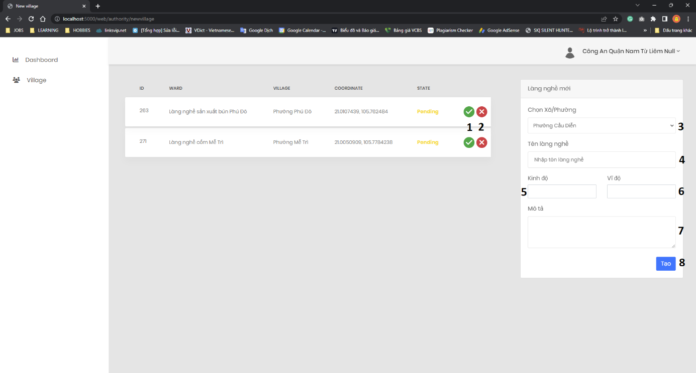

**Figure 15.** UI of Village Management Page

**Table 19.** Elements of UI Village Management Page

|  |  |  |  |  |
| --- | --- | --- | --- | --- |
| From | Condition | Control Type | Target | Notes |
| 1 | Click | Button | Accept the request to add a new craft village |  |
| 2 | Click | Button | Decline the request to add a new craft village |  |
| 3 | Click | DropDownList | Select ward |  |
| 4 | Input | Textbox | Enter the name of village |  |
| 5 | Input | Textbox | Enter longitude |  |
| 6 | Input | Textbox | Enter latitude |  |
| 7 | Input | Textbox | Enter a description of the craft village |  |
| 8 | Click | Button | Add new craft village |  |

## Household

### Login Page



**Figure 16.** UI of Login Page on Website

**Table 20.** Elements of UI Login Page on Website

|  |  |  |  |  |
| --- | --- | --- | --- | --- |
| From | Condition | Control Type | Target | Notes |
| 1 | Input | Textbox | Enter the username |  |
| 2 | Input | Textbox | Enter the password |  |
| 3 | Click | Button | Click to go to home page |  |
| 4 | Click | Hyperlink | Click to go to register page |  |

### Change Password Page



**Figure 17.** UI of Change Password Page

**Table 21.** Elements of UI Change Password Page

|  |  |  |  |  |
| --- | --- | --- | --- | --- |
| From | Condition | Control Type | Target | Notes |
| 1 | Input | Textbox | Enter the current password |  |
| 2 | Input | Textbox | Enter the new password |  |
| 3 | Input | Textbox | Enter the new password again |  |
| 4 | Click | Button | Cancel the password change operation |  |
| 5 | Click | Button | Click to change the password for the account |  |

### Register Page

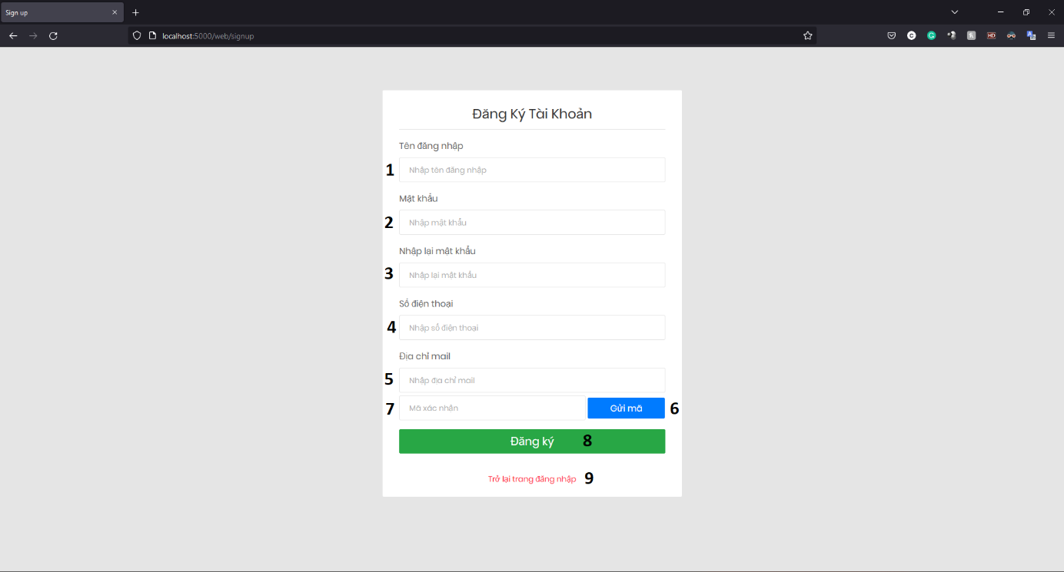

**Figure 18.** UI of Register Page

**Table 22.** Elements of UI Register Page

|  |  |  |  |  |
| --- | --- | --- | --- | --- |
| From | Condition | Control Type | Target | Notes |
| 1 | Input | Textbox | Enter the username |  |
| 2 | Input | Textbox | Enter the password |  |
| 3 | Input | Textbox | Enter the password again |  |
| 4 | Input | Textbox | Enter the phone number |  |
| 5 | Input | Textbox | Enter the email address |  |
| 6 | Click | Button | Click to send confirmation code to email |  |
| 7 | Input | Textbox | Enter the confirmation code from email |  |
| 8 | Click | Button | Click to complete account registration |  |
| 9 | Click | Hyperlink | Click to return the login page |  |

### Household Survey Page

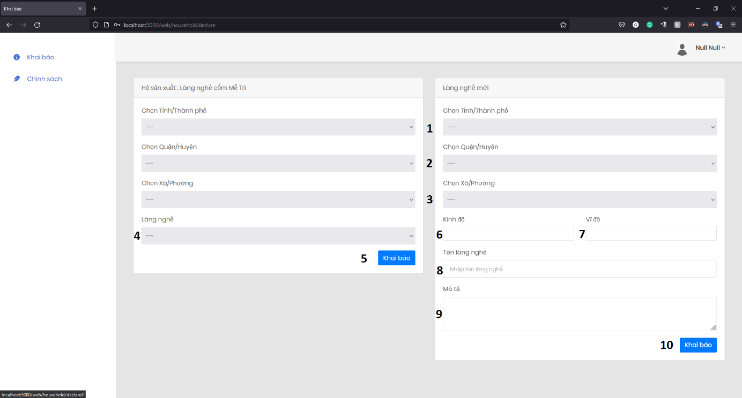

**Figure 19.** UI of Survey Page

**Table 23.** Elements of UI Survey Page

|  |  |  |  |  |
| --- | --- | --- | --- | --- |
| From | Condition | Control Type | Target | Notes |
| 1 | Click | DropDownList | Click to select province/city |  |
| 2 | Click | DropDownList | Click to select district |  |
| 3 | Click | DropDownList | Click to select ward |  |
| 4 | Click | DropDownList | Click to select village |  |
| 5 | Click | Button | Click to declare a new craft village |  |
| 6 | Input | Textbox | Enter the longtitude |  |
| 7 | Input | Textbox | Enter the latitude |  |
| 8 | Input | Textbox | Enter the name of village |  |
| 9 | Input | Textbox | Enter a description of the craft village |  |
| 10 | Click | Button | Click to declare a new craft village |  |

## Admin

### Login Page



**Figure 20.** UI of Login Page on Website

**Table 24.** Elements of UI Login Page on Website

|  |  |  |  |  |
| --- | --- | --- | --- | --- |
| From | Condition | Control Type | Target | Notes |
| 1 | Input | Textbox | Enter the username |  |
| 2 | Input | Textbox | Enter the password |  |
| 3 | Click | Button | Click to go to home page |  |
| 4 | Click | Hyperlink | Click to go to register page |  |

### Change Password Page



**Figure 21.** UI of Change Password Page

**Table 25.** Elements of UI Change Password Page

|  |  |  |  |  |
| --- | --- | --- | --- | --- |
| From | Condition | Control Type | Target | Notes |
| 1 | Input | Textbox | Enter the current password |  |
| 2 | Input | Textbox | Enter the new password |  |
| 3 | Input | Textbox | Enter the new password again |  |
| 4 | Click | Button | Cancel the password change operation |  |
| 5 | Click | Button | Click to change the password for the account |  |

### Create New Local Authority Page

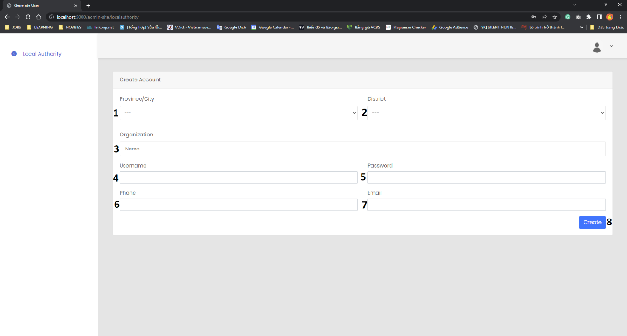

**Figure 22.** UI of Create New Local Authority Page

**Table 26.** Elements of UI Create New Local Authority Page

|  |  |  |  |  |
| --- | --- | --- | --- | --- |
| From | Condition | Control Type | Target | Notes |
| 1 | Click | DropDownList | Click to select province/city |  |
| 2 | Click | DropDownList | Click to select district |  |
| 3 | Input | Textbox | Enter the name of organization |  |
| 4 | Input | Textbox | Enter the username |  |
| 5 | Input | Textbox | Enter the password |  |
| 6 | Input | Textbox | Enter the phone number |  |
| 7 | Input | Textbox | Enter the email address |  |
| 8 | Click | Button | Click to create a new local authority |  |